**Assignment –2**

**Connect to the Store Sales Data and do the following: -**

Remove all the blank rows.

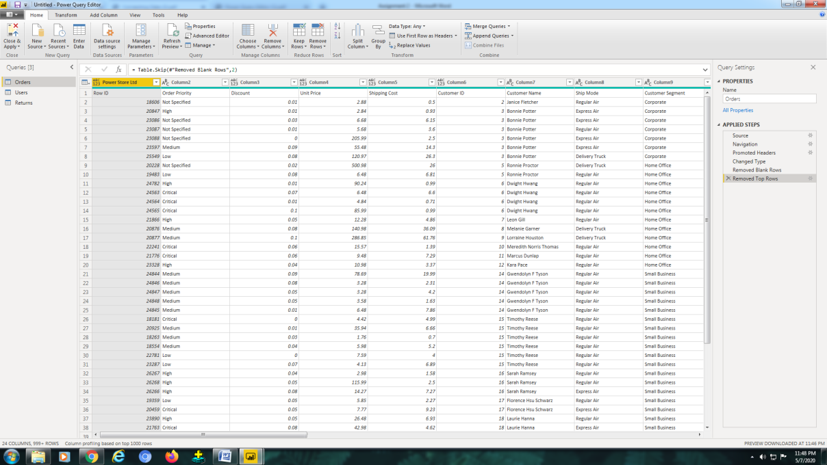

Update the column header if they are not updated :

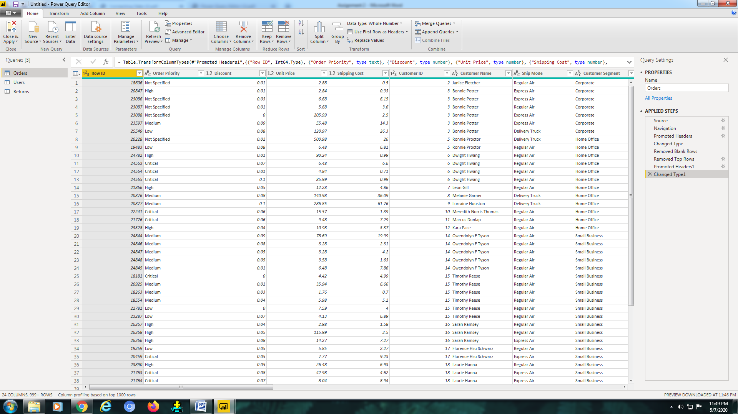

Create a text table and show the sales in terms of

Customers ,Product Category and Regions :

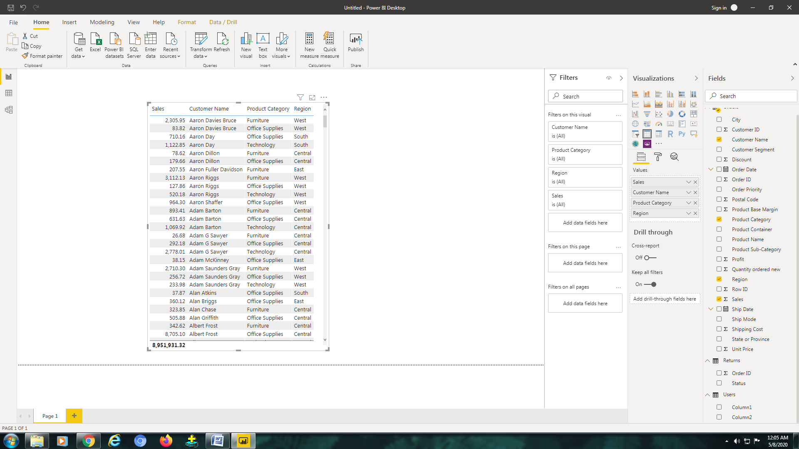

Create a line and Clustered Column Chart showing the Sales and Discount as per the State or Province

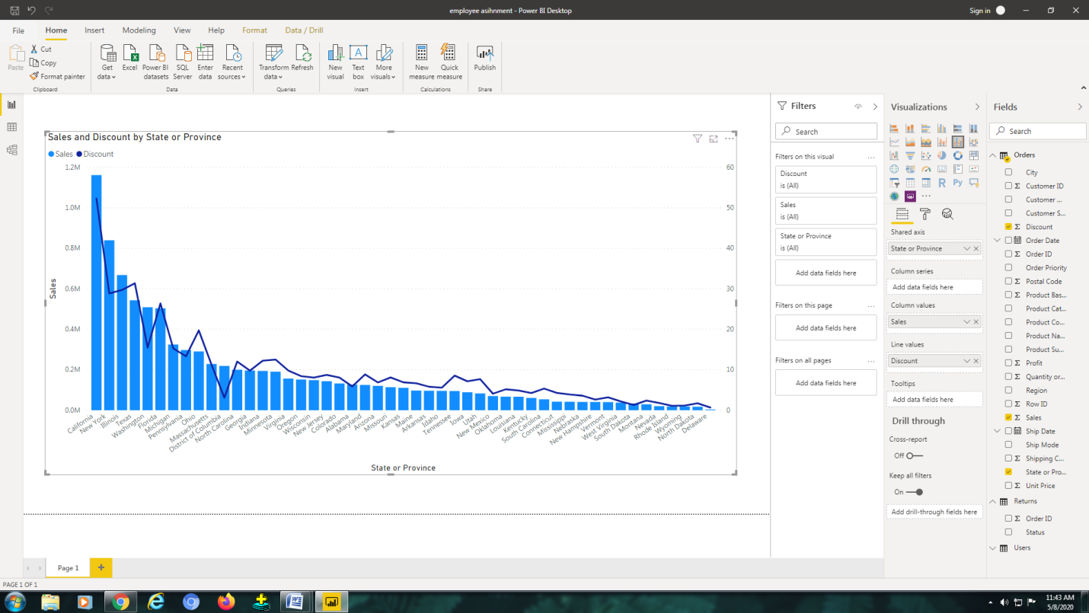

−

Which state has the highest sales in terms Technology :

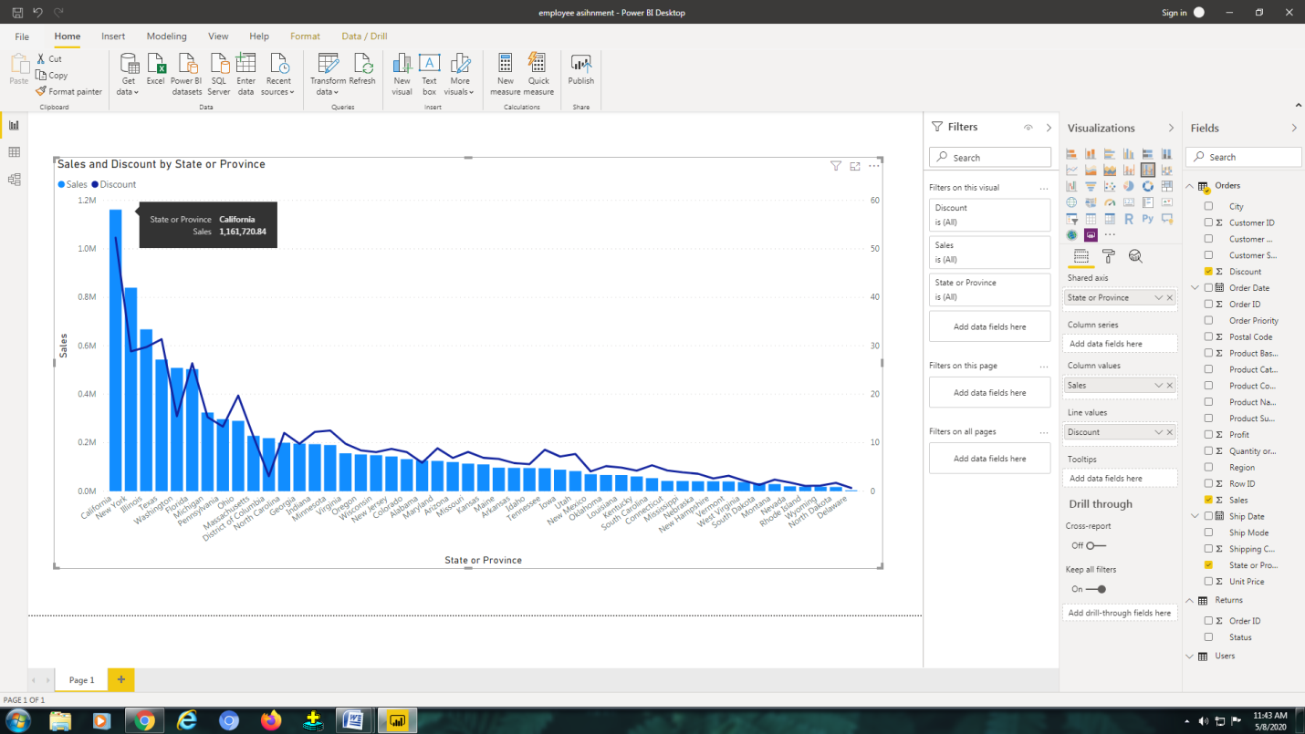

• Create a Donut Chart showing sales in terms of Product category

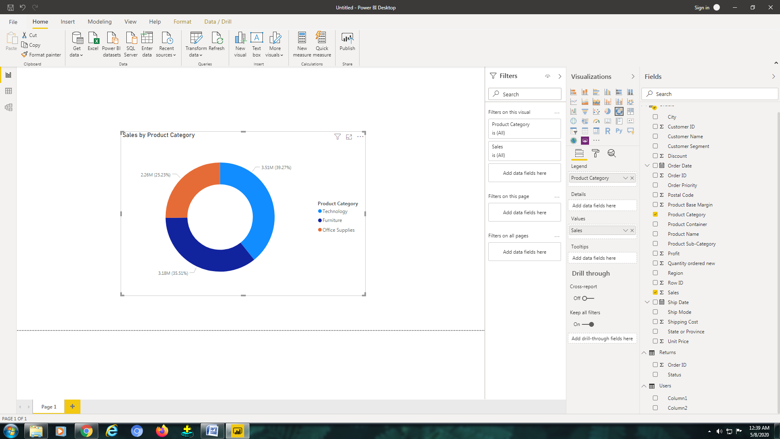

Create a Slicer and show the regions in dropdown. See how all the visuals mentioned above behaving when a particular region is selected.

